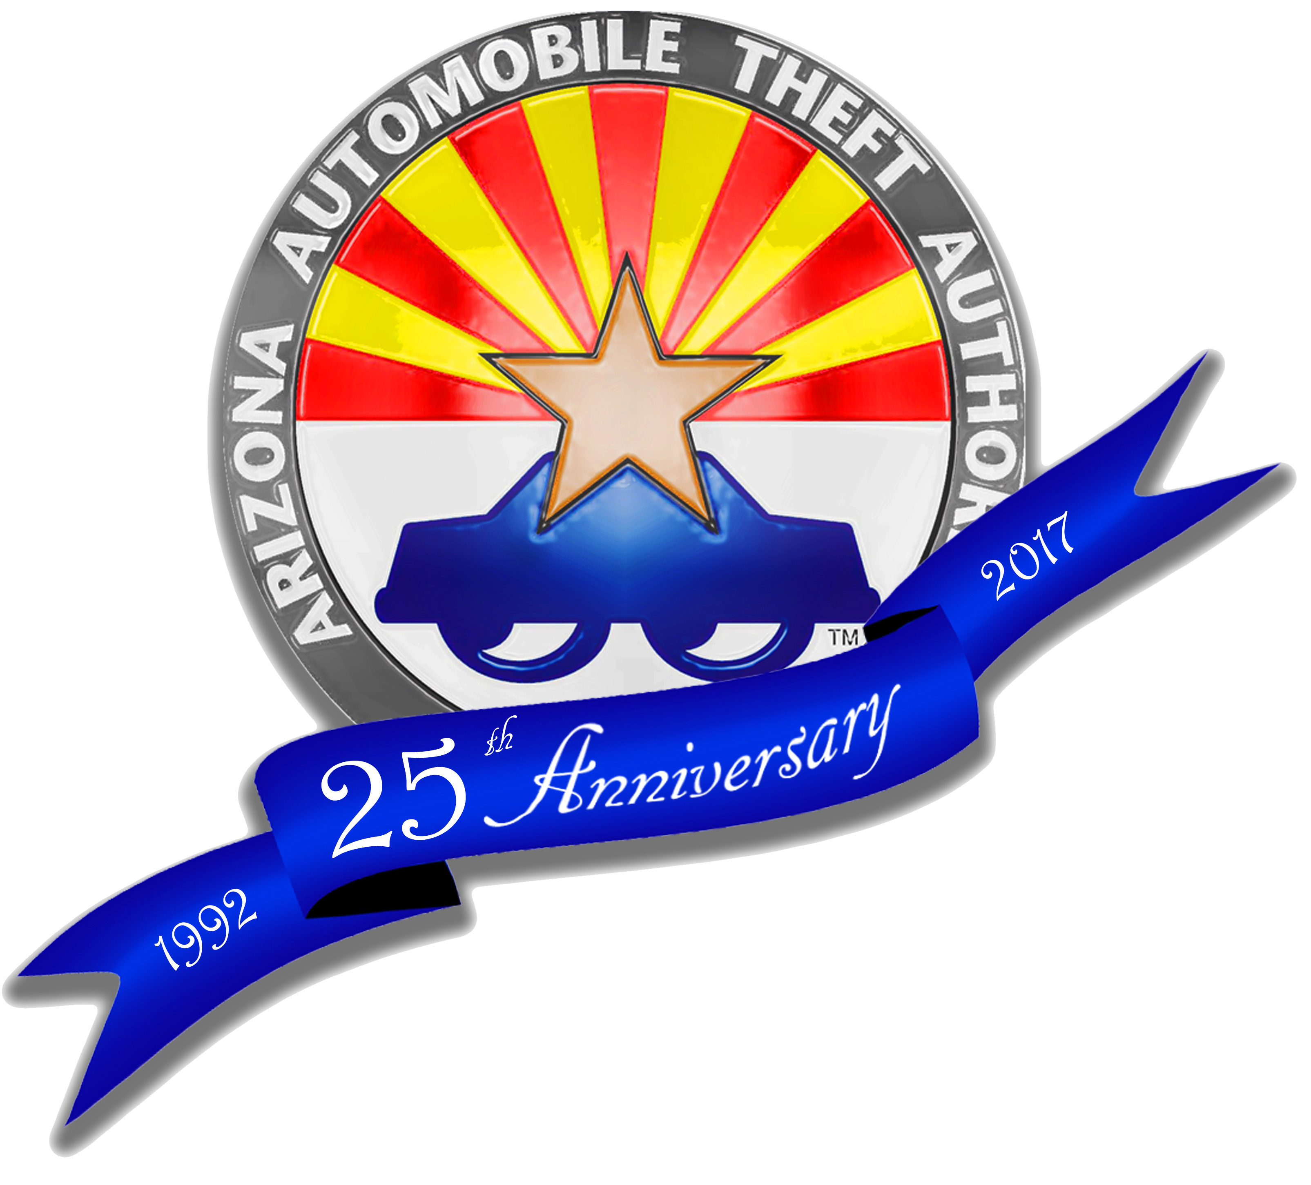

State of Arizona

Arizona Automobile

Theft Authority

www.azwatchyourcar.com

News Release

For More Information

Contact: Ann Armstrong

Arizona Automobile

Theft Authority

Phone: 602 364-2892
ann.armstrong@aata.az.gov



News Release

February 28, 2017

Arizona Automobile Theft Authority Celebrates 25th Anniversary with
Auto Theft Prevention Month Kickoff Event – Friday, March 3, 2017

PHOENIX – This year, the Arizona Automobile Theft Authority (AATA) celebrates 25 years (1992-2017) of fighting auto theft crimes and reports a nearly 60% decrease in statewide thefts since inception.

Arizona, once the #1 state for auto thefts per capita, now ranks 15th in the nation! Last year, the Phoenix MSA (Metro Statistical Area), once know nationwide as the “Car Theft Capitol” of the U.S., plunged down the list to 80th place; Tucson, previously #2, fell to #99; Yuma #103. According to AATA Director, Fred Zumbo, “AATA’s longtime enforcement, prosecution and prevention partners are impacting the state’s auto theft rates; however, auto theft remains a major public issue so our fight is not over. More sophisticated technologies and strategies are being actively deployed to aid in our fight.”

In the early 1990’s as Arizona’s auto theft rates were sky rocketing, the Legislature created the Automobile Theft Authority to serve as the State’s lead organization working with law enforcement, prosecutors and the community to combat auto crimes across Arizona. The Authority is self-funded through an annual assessment of insurance companies in Arizona; no State General Fund monies are used.

This Friday, March 3rd, the AATA & Arizona Vehicle Theft Task Force will kick-off celebrations and the start of the 12th Annual Auto Theft Prevention Month this March by hosting a Free Vehicle Identification Number (VIN) Window Etching from 9:00am – 1:00pm at Wesley Bolin Plaza (NE parking lot) -1616 W. Washington Street.

Other popular AATA prevention and outreach programs include the Watch Your Car decal program, “Watch Your Tail” Tailgate Theft Prevention DIY tips & kits, Carjacking Prevention and the Annual Auto Theft Prevention Month, Visit the AATA Events Calendar for a complete listing of events https://aata.az.gov/upcoming-events.


